Spam Filtering
From BMA Enterprises, Inc. (ABA2NET.COM)

In our never ending battle to minimize spam we have implemented a new spam fighting system. This new system (like our previous spam notification system) evaluates all email and assigns a score to each message in order to determine the likelihood of it being spam versus a legitimate email. The new system allows you to control a number of configuration options to tighten or loosen the spam thresholds.

Most spam filters set a default value of 5.0 as the threshold for spam. We have found that a setting of 3.0 may be more appropriate and result in fewer spam messages arriving in your mailbox. You will need to change the default settings if you wish to use a different score other than 5.0. This reduced setting, in addition to creating whitelists of email addresses for whom you wish to accept email, will greatly reduce the spam you receive (provided you have your configuration set to quarantine your spam as opposed to simply labeling it). Please read the following instructions for information on how to access the new spam filter and customize your spam filter configuration.

- Open your browser for example Internet Explorer
- In the address bar type the following web site address http://spamfilter.aba2net.com
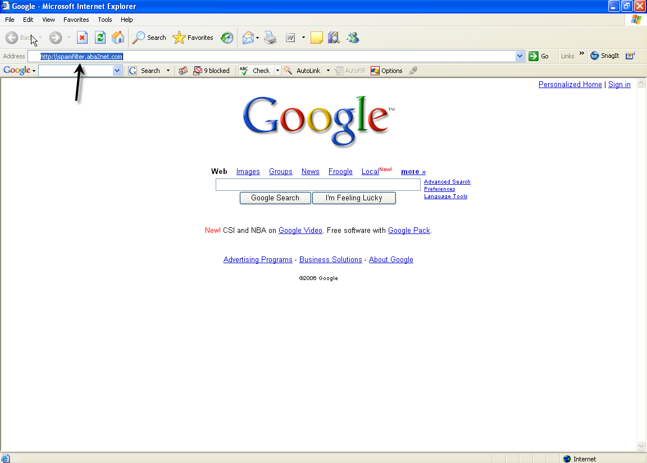

- This will take you to the spam filter login screen

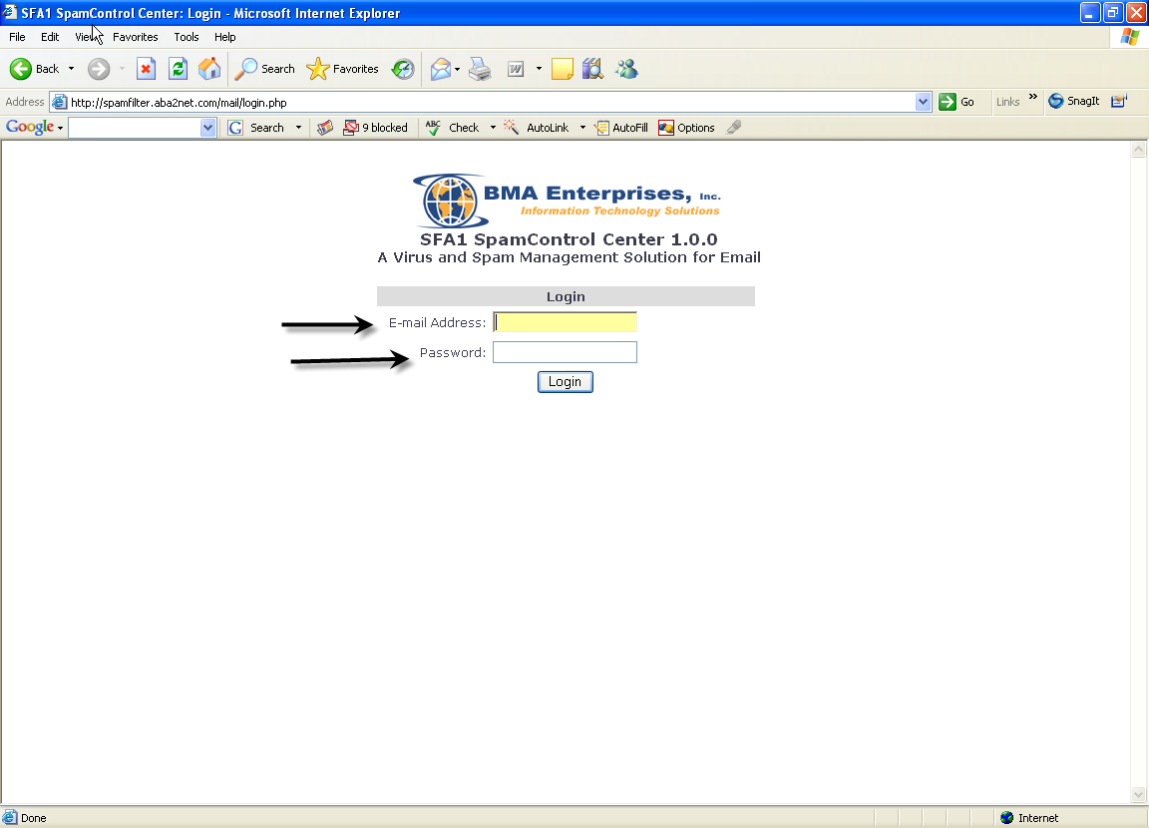

- Login using your email address and password

- Upon logging in you will be directed to the SFA1 Spam Control Center Welcome page

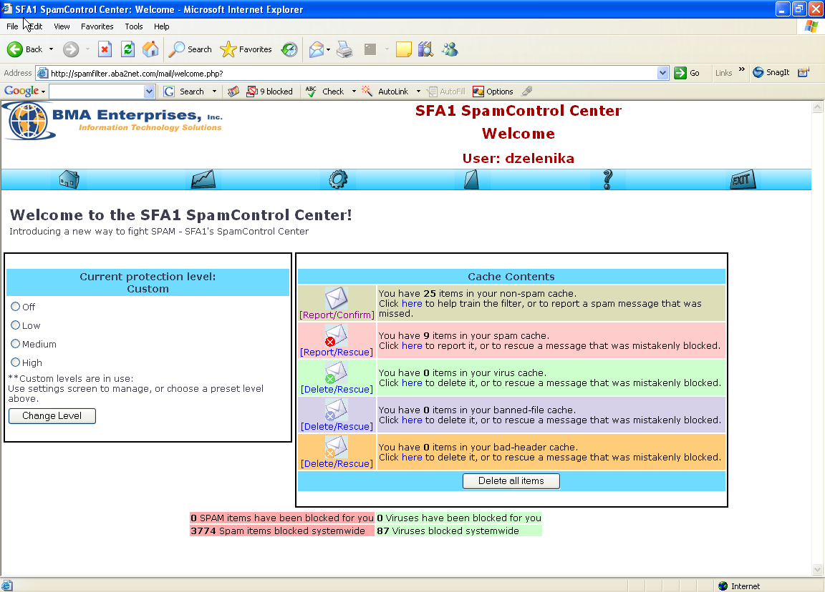
- The welcome page allows you to review messages marked as HAM (good e-mail), SPAM and those containing Viruses. Periodically review your messages marked as SPAM to determine e-mail addresses that need to be added to your whitelist and help “train” the spam filter to more accurately determine which messages are spam and which are not.

- At the top of Welcome page you will also notice six menu options. The arrows in the following screen shot indicate the menu options.

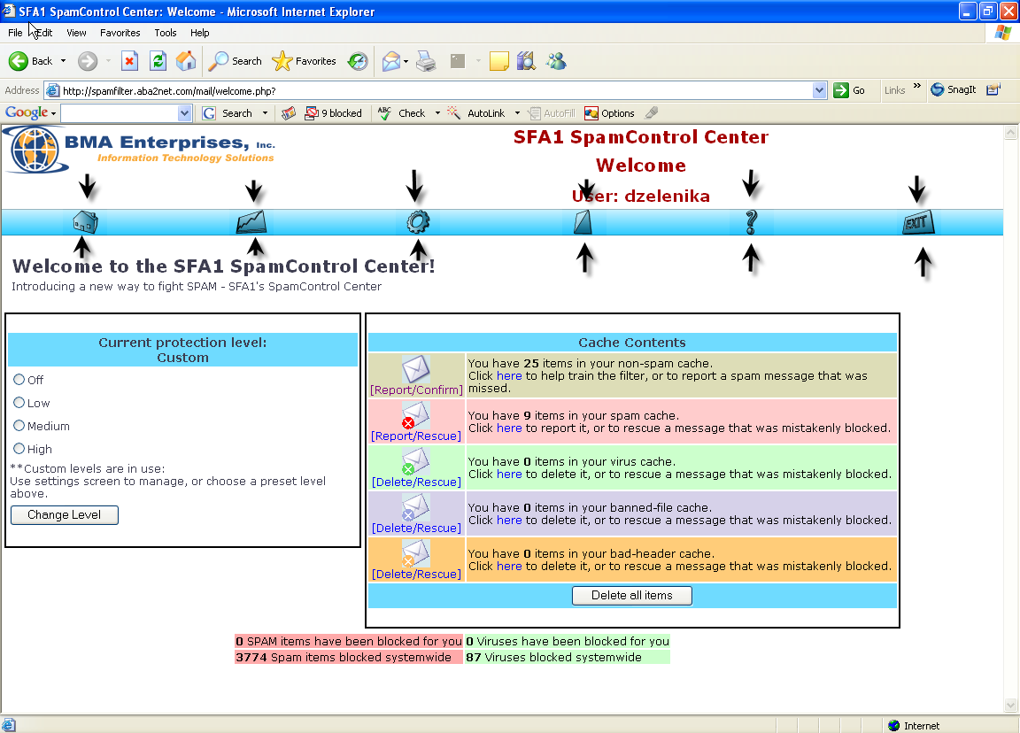

Welcome Page – Maia is one of several programs that make up the SFA1 gateway and allows you to configure your spam settings the way you want them. The Welcome page contains a quick overview of all the activity Maia has done on your behalf. It also has a simple way to select various levels of protection for your email account.
We have created custom protection for our customers so the “Current protection level” shown on the left side of the Welcome page should say “Custom”. You may change the setting if you like.
A list of all the categories of email Maia scans is also listed, along with how many items are suspected to be in that category (Ham / Spam / Virus / etc.). This is where you can help fight against unwanted email. More information about these categories can be found below.

Stats – Your status page displays a statistical summary of the mail that Maia has processed for you, divided into categories by type. This can be very interesting in seeing just how much of your total e-mail is Spam.

Mail Filter Settings – Maia allows you to maintain different mail filter settings for each of the e-mail addresses you have access to at this site. You can consolidate all of these addresses under one Maia user account to make it easier to manage them all from one interface.
W/B lists – Your whitelist lets you specify that mail coming from specific senders (or entire domains) should not be spam-checked, and should be delivered to you regardless of its content. It's a way of making sure that you don't inadvertently block mail from people you know and trust.
Your blacklist is effectively the opposite of your whitelist – it lets you specify that mail coming from specific senders (or entire domains) should never be delivered to you, under any circumstances. Senders on this list will be blocked, regardless of the content of their mail.
Help – Contains a detailed description of the spam control features.

Exit – Logs the user out of the spam control center.

- At the Welcome page the Cache Contents displays a number of messages where you will be able to set the rules for handling messages. For example you will notice 25 items in the non-spam cache. To view these messages select Report/Confirm.

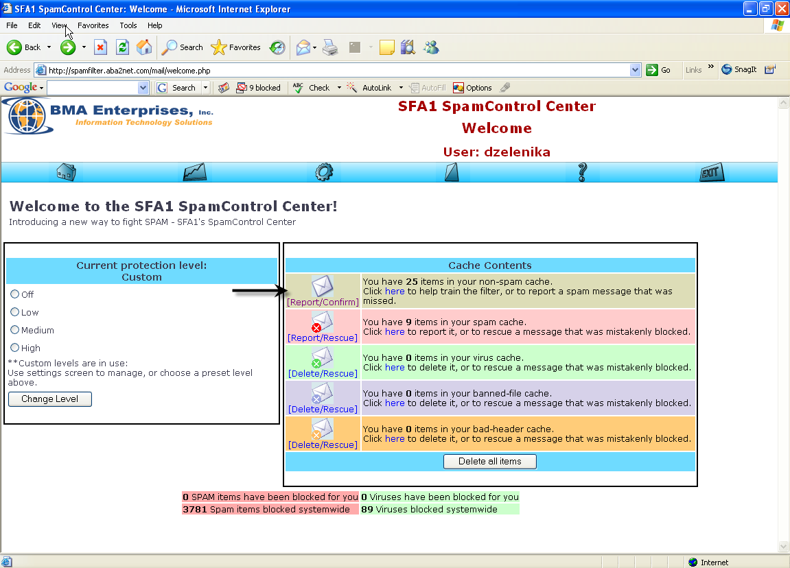

- The un-confirmed messages are displayed in the next screen shot. These messages are what Maia considered as probable legitimate email or non spam.
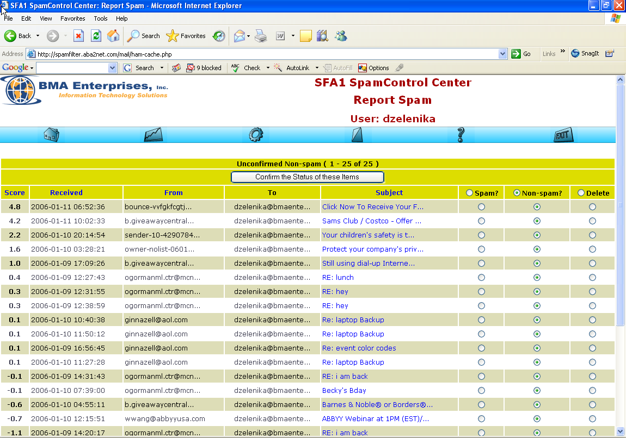

These messages are sorted according to the score. They can also be sorted by the date received, who it was sent from, or by the subject just by clicking on the desired column heading.

The unconfirmed Non-spam messages are what Maia thinks is non spam. You will need to go through these messages to confirm the diagnosis.

The messages are already listed as non spam, if you think Maia made a mistake you can change the status of the message to spam. To confirm status select “confirm the status for these items” for the change to take effect. This process will help train the filter system to more accurately determine future messages as spam or not.
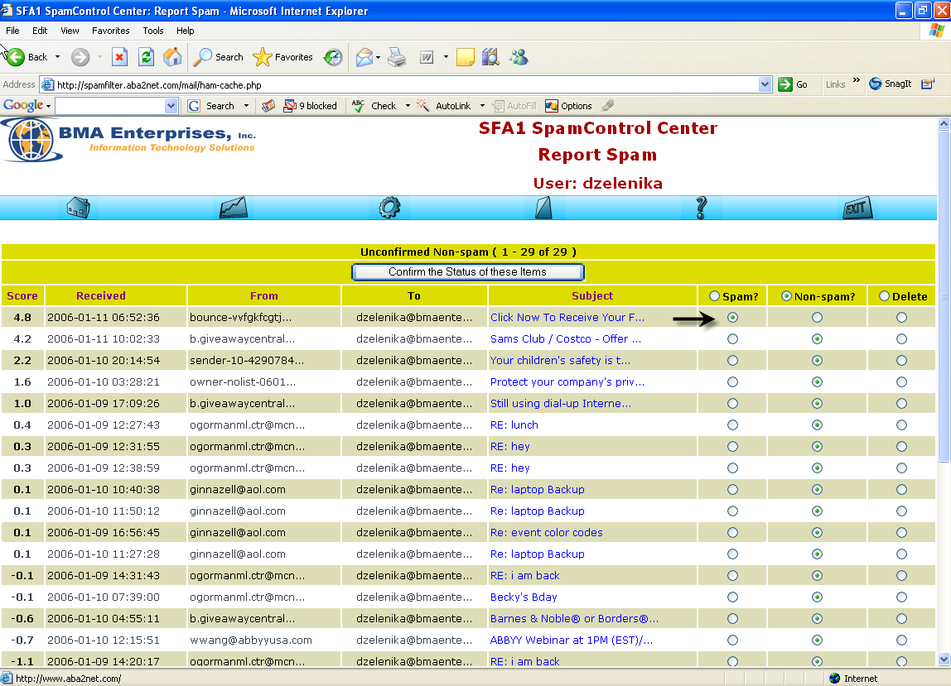

Suspected Spam items are non-legitimate email addresses.
Non-spam items are legitimate emails.
The delete option lets you remove the item without confirming or denying that it is spam.

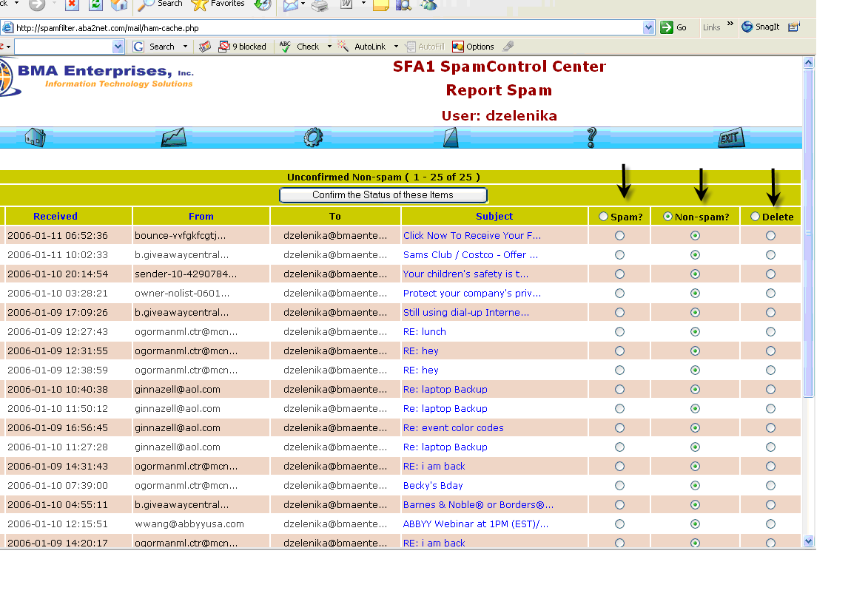

- At the Welcome screen after confirming the non – spam cache you can go ahead and confirm your spam cache. These are a list of messages that were mistakenly blocked.

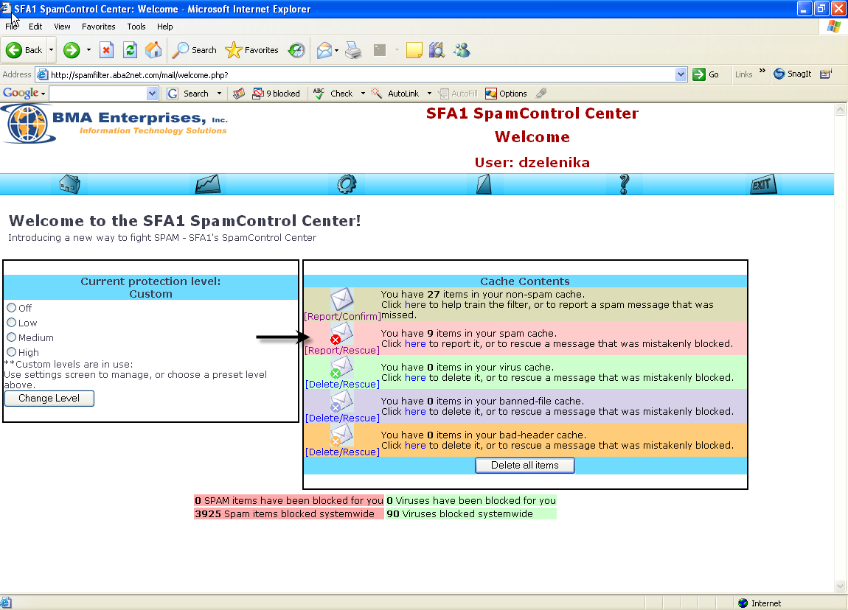

All the messages here will be listed as spam and can be sorted according to any of the listed categories. If a message was blocked by mistake you will need to make the necessary change and unblock the message by selecting any one of the following options.

Suspected Spam items are non-legitimate email addresses.
Non-spam items are legitimate emails.
The delete option lets you delete the item without confirming or denying that it is spam.

Select “Confirm the status of these items” for changes to take effect.

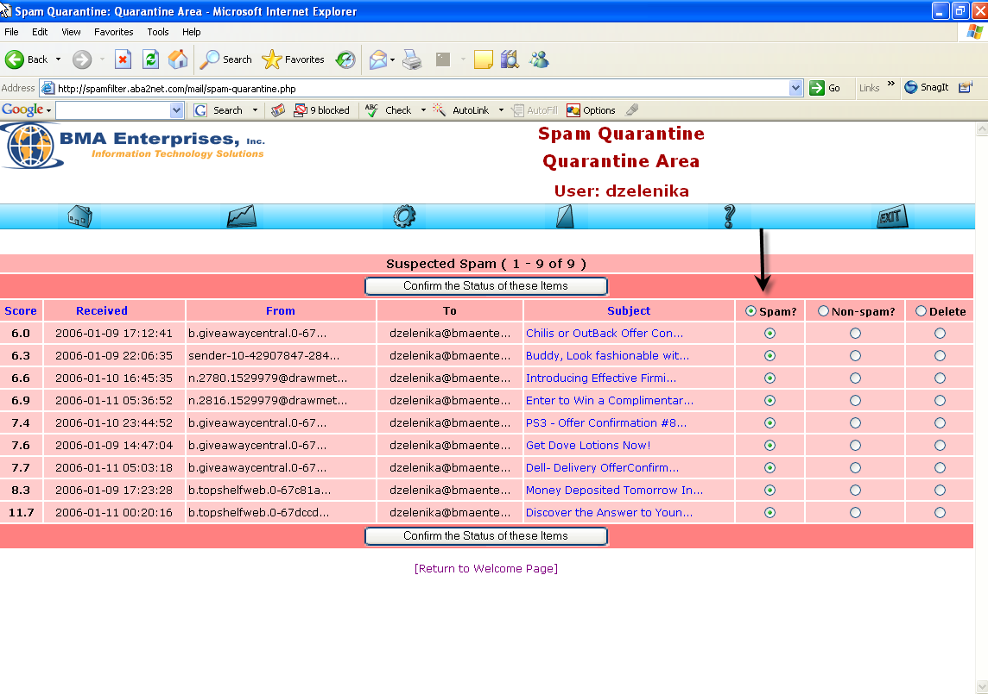

- By now you should have an understanding of how to change status of messages. We’ll go ahead and describe some of the other cache features.

Virus/Malware items (if any) are listed after any spam items. This list is sorted by date, and includes the name of the virus(es) that were found in the mail, along with the sender's (supposed) e-mail address and the subject line. The mail viewer is safe to use if you want to look at the text portion of the e-mail, since it will only decode text and HTML elements, not binary attachments. There is a non-spam option in case you really, really want the virus-infected mail sent to your computer (presumably for special processing of some sort). Obviously use the non-spam option with great caution, or not at all. Generally all you should be doing with these virus items is clicking the “Confirm the status of these items button at the bottom of the page.
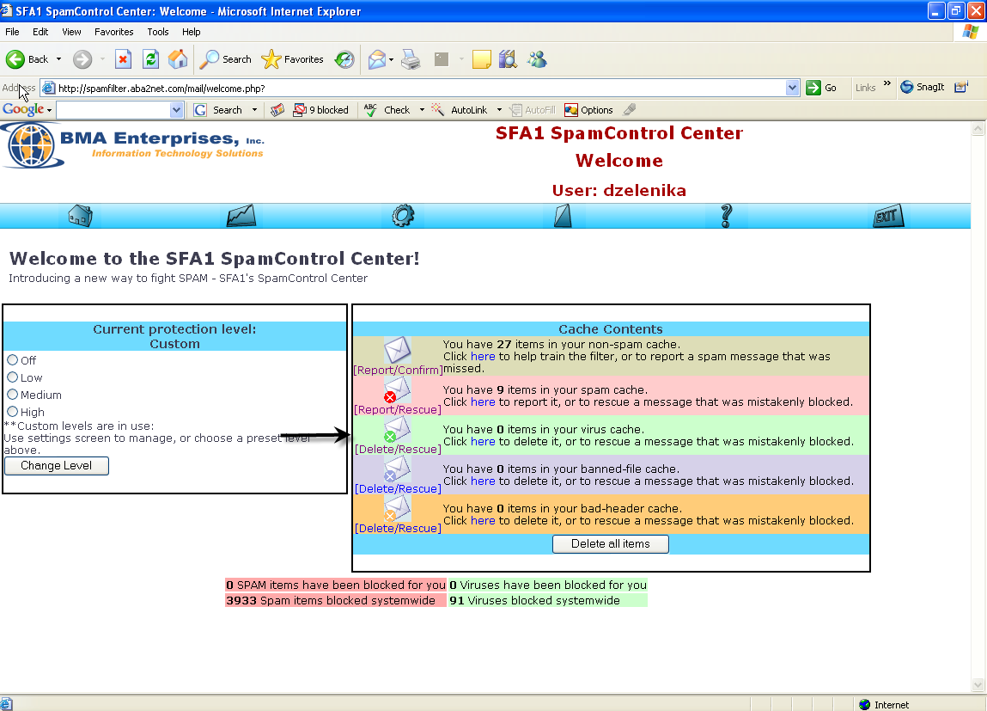

Banned File Attachments (if any) are listed after any virus items. This list is sorted by date, and includes the names of the file attachments that were found in the mail, along with the sender's (supposed) e-mail address and the subject line. You can use the mail viewer by clicking on the subject line of the mail, if you want to check out the contents of the mail itself, and you can use the non spam option to have the item redelivered if you wish. The Confirm the Status of these Items button at the bottom will clear the list for you, and rescue all of the items you requested.
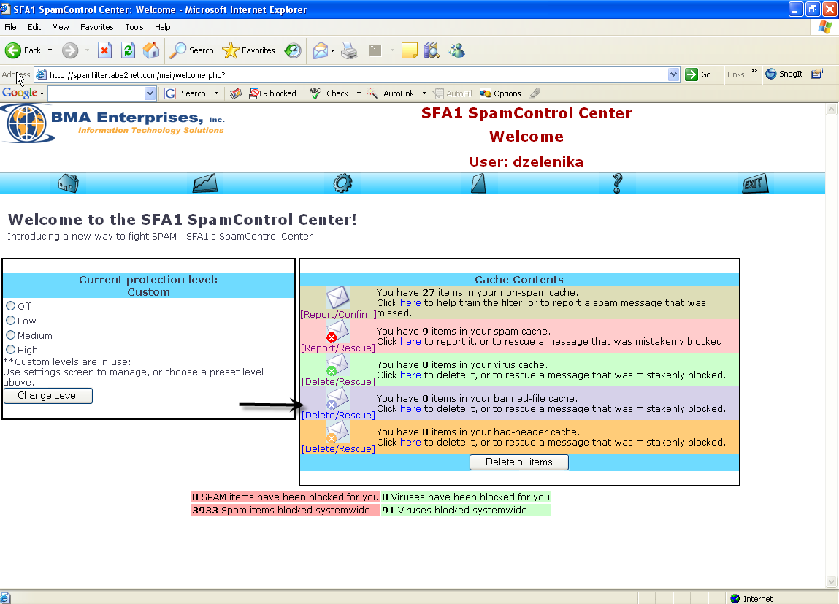

Invalid Mail Headers (if any) are listed after any banned file attachments. This list is sorted by date, and simply lists the sender's (supposed) e-mail address and subject line. You can use the mail viewer by clicking on the subject line of the mail, if you want to check out the contents of the mail itself, and you can use the non-spam option to have the item redelivered if you wish. The Confirm the Status of these Items button at the bottom will clear the list for you, and rescue all of the items you requested.
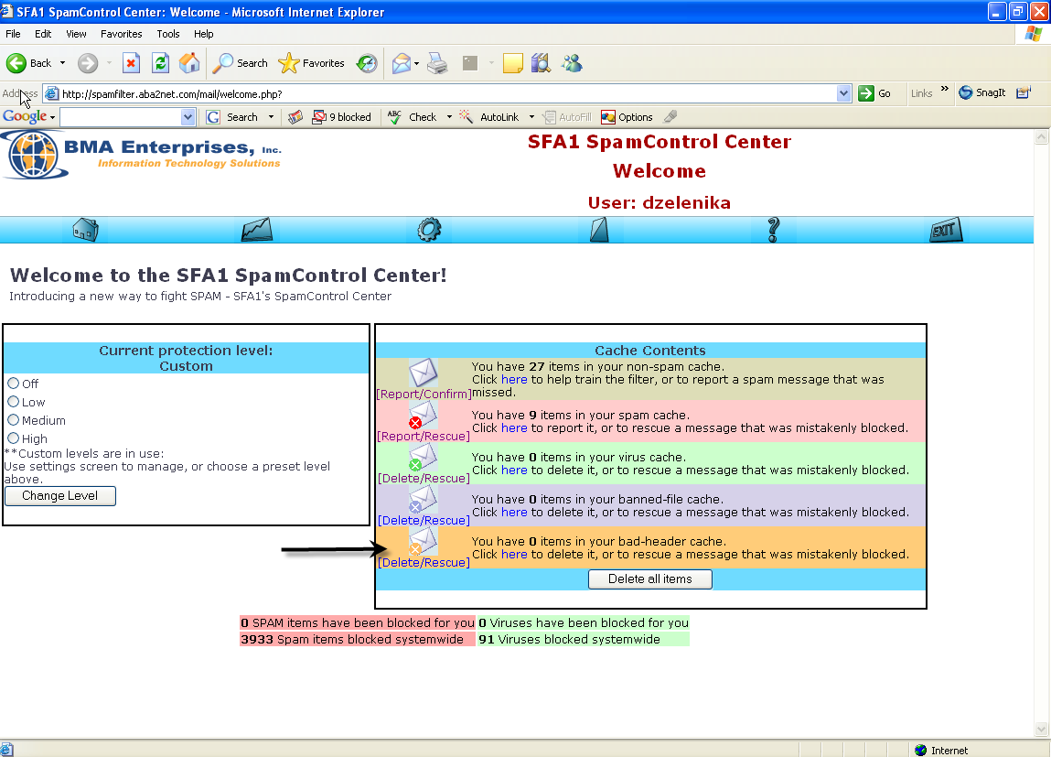

As a footnote, when you "confirm spam", you're not just deleting the mail, you're effectively helping to prevent others from receiving that spam in the future. The confirmed spam items are studied by Maia's learning engines, and then passed along to other spam-filtering networks on the Internet. Similarly, when you use the non-spam option to rescue an item from your spam quarantine, you're helping the learning engine recognize what legitimate mail looks like, so that it's less likely to make the same mistake in the future.
You'll want to check your quarantine area regularly to make sure you haven't missed any important mail, and of course to clear out the items that have accumulated since the last time you checked in. Items that go unconfirmed for 30 days are automatically deleted, and cannot be submitted to the learning engines, so please try to keep your quarantine area up-to-date.
If you don't have time to confirm the items in your quarantine area, or there are simply too many of them to bother with (e.g. you just got back from a two-week vacation and there are thousands of items waiting to be confirmed, etc.), you can use the Delete ALL Quarantined Items button to delete all the items in the quarantine area without reporting them. Obviously this isn't very helpful to Maia's learning process, but it's better to just delete items than to "confirm" items blindly and have Maia learn the wrong things.
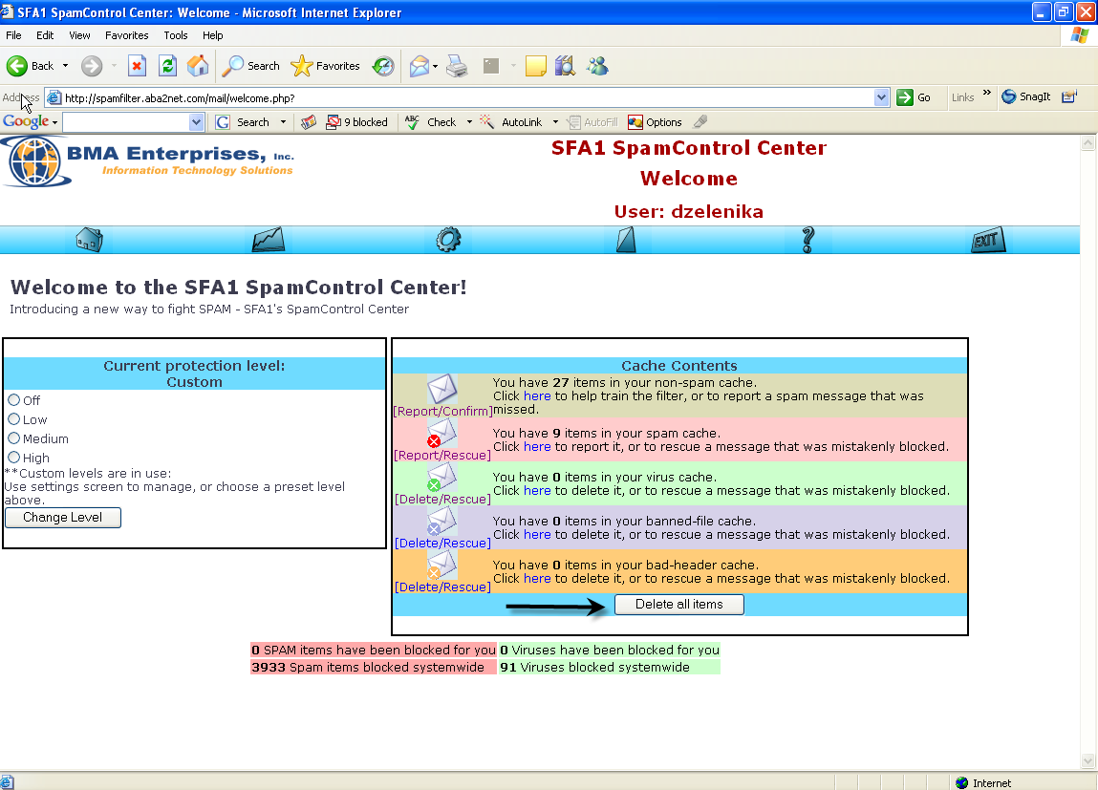
To Logout select Exit
